# EXPERIMENT NO: 9

KNN

**Aim:**

To write the Python program to understand and perform classification using the K-Nearest Neighbors (KNN) algorithm on the given dataset..

**Algorithm:**

1. Load the dataset and examine its structure and contents.
2. Identify the feature columns and the target label.
3. Split the dataset into training and testing sets.
4. Initialize the KNN classifier with a chosen number of neighbors.
5. Train the classifier using the training data.
6. Evaluate the model's performance using accuracy and confusion matrix.

**

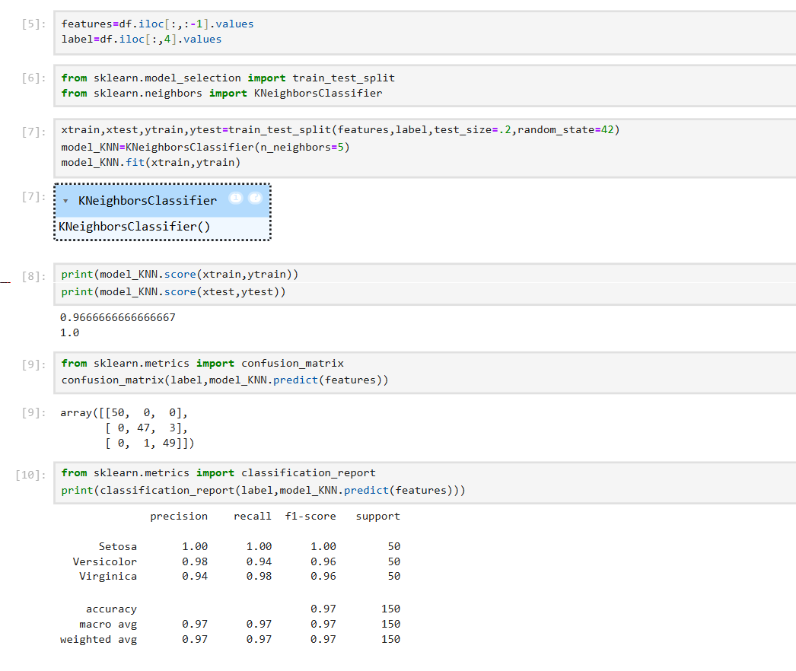

**Result:**

Thus, the Python program is executed successfully for classifying the given dataset using the KNN algorithm.